Adjacent Right and Acute Angles

Definition
# Source: AI Source: Provided by: [Data Path: Persons Table -> ID Column: 1, Name_En Column: Motasem Essam] -> From: [ChatGPT] on [7/25/2026]
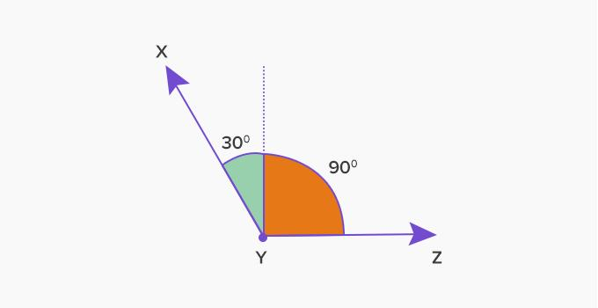
Adjacent Right and Acute Angles are two adjacent angles where:
- One angle is a right angle, measuring exactly ${90}^{∘}$.
- The other angle is an acute angle, measuring more than $0^{∘}$and less than ${90}^{∘}$.
- Both angles share the same vertex.
- They share one common side.
- Their interiors do not overlap.
If the right angle is $∠ABC$and the acute angle is $∠CBD$, then:
$$m∠ABC={90}^{∘}$$
and
$$0^{∘}<m∠CBD<{90}^{∘}$$
Therefore, their combined measure is:
$${90}^{∘}+θ$$
where
$$0^{∘}<θ<{90}^{∘}$$
so:
$${90}^{∘}<{90}^{∘}+θ<{180}^{∘}$$
Thus, the combined angle is always obtuse.

Simple Definition
# Source: AI Source: Provided by: [Data Path: Persons Table -> ID Column: 1, Name_En Column: Motasem Essam] -> From: [ChatGPT] on [7/25/2026]
Adjacent Right and Acute Angles are adjacent angles in which one angle is ${90}^{∘}$and the other is less than ${90}^{∘}$.

Example
# Source: AI Source: Provided by: [Data Path: Persons Table -> ID Column: 1, Name_En Column: Motasem Essam] -> From: [ChatGPT] on [7/25/2026]
Suppose two adjacent angles have measures:
$${90}^{∘} \text{and} {30}^{∘}$$
Then:
$${90}^{∘}+{30}^{∘}={120}^{∘}$$
Since ${120}^{∘}$is greater than ${90}^{∘}$and less than ${180}^{∘}$, the combined angle is obtuse.

Conditions
# Source: AI Source: Provided by: [Data Path: Persons Table -> ID Column: 1, Name_En Column: Motasem Essam] -> From: [ChatGPT] on [7/25/2026]
For two angles to be classified as Adjacent Right and Acute Angles, they must satisfy all of the following:
1. Common Vertex
Both angles have the same vertex.
For example:
$$∠ABC$$
and
$$∠CBD$$
both have vertex $B$.
2. Common Side
The two angles share one side.
For example, both angles share:
$$\vec{BC}$$
3. Non-Overlapping Interiors
The interiors of the two angles do not overlap.
4. One Angle Is Right
$$m∠ABC={90}^{∘}$$
5. The Other Angle Is Acute
$$0^{∘}<m∠CBD<{90}^{∘}$$

More Examples
# Source: AI Source: Provided by: [Data Path: Persons Table -> ID Column: 1, Name_En Column: Motasem Essam] -> From: [ChatGPT] on [7/25/2026]
Example 1: ${90}^{∘}+{20}^{∘}$
$${90}^{∘}+{20}^{∘}={110}^{∘}$$
The resulting angle is obtuse.
Example 2: ${90}^{∘}+{45}^{∘}$
$${90}^{∘}+{45}^{∘}={135}^{∘}$$
The resulting angle is obtuse.
Example 3: ${90}^{∘}+{60}^{∘}$
$${90}^{∘}+{60}^{∘}={150}^{∘}$$
The resulting angle is obtuse.
Example 4: ${90}^{∘}+{89}^{∘}$
$${90}^{∘}+{89}^{∘}={179}^{∘}$$
The resulting angle is still obtuse.
In general:
$${90}^{∘}+\text{acute angle}=\text{obtuse angle}$$

Important Relationship
# Source: AI Source: Provided by: [Data Path: Persons Table -> ID Column: 1, Name_En Column: Motasem Essam] -> From: [ChatGPT] on [7/25/2026]
Adjacent right and acute angles are not complementary.
Complementary angles must satisfy:
$$A+B={90}^{∘}$$
But here:
$${90}^{∘}+θ>{90}^{∘}$$
because:
$$θ>0^{∘}$$
Therefore:
$${90}^{∘}+θ≠{90}^{∘}$$
So an adjacent right angle and a nonzero acute angle cannot be complementary.

Comparison
# Source: AI Source: Provided by: [Data Path: Persons Table -> ID Column: 1, Name_En Column: Motasem Essam] -> From: [ChatGPT] on [7/25/2026]
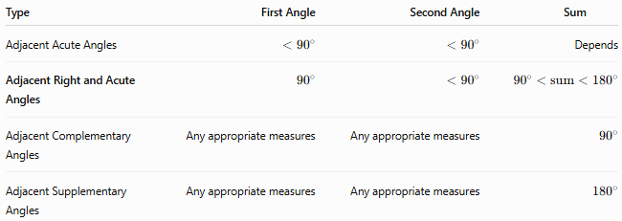
Type | First Angle | Second Angle | Sum
Adjacent Acute Angles | $$<{90}^{∘}$$ | $$<{90}^{∘}$$ | Depends
Adjacent Right and Acute Angles | $${90}^{∘}$$ | $$<{90}^{∘}$$ | $${90}^{∘}<\text{sum}<{180}^{∘}$$
Adjacent Complementary Angles | Any appropriate measures | Any appropriate measures | $${90}^{∘}$$
Adjacent Supplementary Angles | Any appropriate measures | Any appropriate measures | $${180}^{∘}$$

Important Distinction
# Source: AI Source: Provided by: [Data Path: Persons Table -> ID Column: 1, Name_En Column: Motasem Essam] -> From: [ChatGPT] on [7/25/2026]
Adjacent describes the geometric relationship between the angles.
Right and acute describe their measures.
Therefore:
$$\boxed{\text{Adjacent}+\text{Right/Acute}}$$
describes both where the angles are located and what their measures are.
This is a descriptive subtype of adjacent angles rather than a universally standardized named category in all geometry textbooks.

Key Formula
# Source: AI Source: Provided by: [Data Path: Persons Table -> ID Column: 1, Name_En Column: Motasem Essam] -> From: [ChatGPT] on [7/25/2026]
If one adjacent angle is right and the other is acute:
$$\boxed{{90}^{∘}+θ}$$
where:
$$\boxed{0^{∘}<θ<{90}^{∘}}$$
Therefore:
$$\boxed{{90}^{∘}<{90}^{∘}+θ<{180}^{∘}}$$
So their combined angle is always obtuse.

Key Points
# Source: AI Source: Provided by: [Data Path: Persons Table -> ID Column: 1, Name_En Column: Motasem Essam] -> From: [ChatGPT] on [7/25/2026]
- One angle measures exactly ${90}^{∘}$.
- The other angle measures between $0^{∘}$and ${90}^{∘}$.
- They share a vertex and one common side.
- Their interiors do not overlap.
- Their sum is always between ${90}^{∘}$and ${180}^{∘}$.
- Therefore, their combined angle is always obtuse.
- They are not complementary.
- They are not necessarily a linear pair.

Conclusion
# Source: AI Source: Provided by: [Data Path: Persons Table -> ID Column: 1, Name_En Column: Motasem Essam] -> From: [ChatGPT] on [7/25/2026]
Adjacent Right and Acute Angles consist of a ${90}^{∘}$right angle next to an acute angle. If the acute angle measures $θ$, their combined measure is ${90}^{∘}+θ$, which is always an obtuse angle.

